(Approx. 731 words)

Windows 10 Paint 3D
By Len Nasman, Editor, Bristol Village Computer Club, OH
April-May 2018 issue, BVCC Newsletter
http://bvres.org/bvcchome.html
webmaster (at) bvres.org

Microsoft has included a simple paint program with all earlier versions of Windows. In the latest update to Windows 10, a new version of Paint, called Paint 3D, is included. The addition of being able to create and edit 3D images is a significant change to the Paint program You can open Paint 3D from the Start menu.

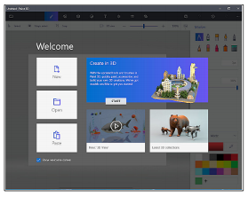
If you search YouTube for Paint 3D you will find a long list of efforts by various individuals to create Paint 3D tutorials. Microsoft has provided their own introduction video.
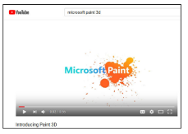
If you want to see a list of YouTube videos from Microsoft that deal specifically with Paint 3D, click on this link.
https://www.youtube.com/playlist?list=PLWs4_NfqMtozAC5tdXutbdiu28Tk4rG5j

For 3rd party YouTube tutorials for Paint 3D, enter Paint 3D tutorials in the YouTube search box.

Microsoft has not provided a user manual for Paint 3D. Instead they seem to be relying on YouTube videos to demonstrate various features of the program. If you are new to this stuff, it might be helpful to learn some of the basics of the user interface. Here are a few tips for using Paint 3D.
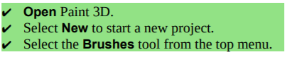
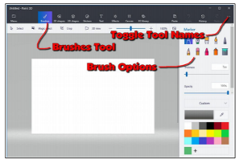
Selecting the Brushes tool displays 10 brush options in the right-side panel. This panel also provides options for Thickness, Opacity, Material, and Color. You can adjust Thickness and Opacity either by entering a value in a text box, or by using a slider found beneath the option.
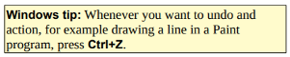
If you hover the mouse cursor over a brush, a tool tip will pop up showing the name of the brush.
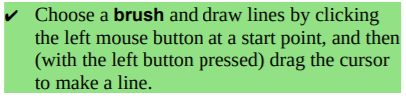
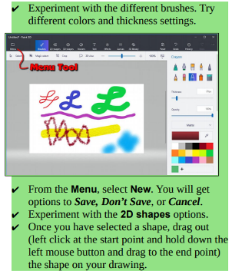
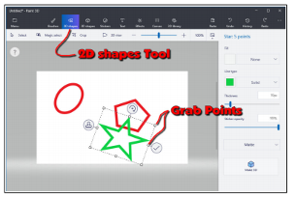
Once you drag out a shape, the right-side panel will show options for modifying the shape.

- Change the Fill, Line Type, Thickness, and Opacity options.

- Grab Points at the corners and mid points of the shape let you change the size and proportions of the shape.

- Rotate tool is used to rotate the shape.

- Check mark tool completes the shape. You can also complete a shape by clicking somewhere away from the shape.

- Clone tool makes a copy of the shape. Here is an example of using the clone tool. See if you can duplicate the drawing.

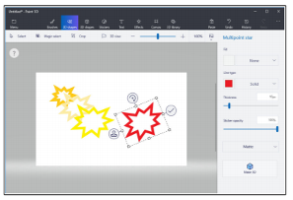
First a multipoint star was dragged out. The clone tool was selected, and the new star was moved, resized, and the color was changed.

This clone process was repeated to make the yellow star. The process was repeated again, and the red star was rotated.

What about 3D? Here is an example of creating 3D text. Select the Text tool, and then select the 3D Text option.
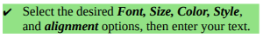
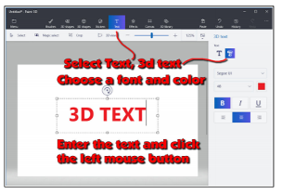
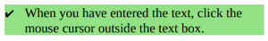
This will open 3D text control tools. When the control tools are open, the text will be highlighted in cyan.
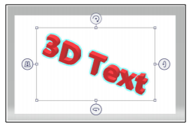
To increase the text depth, use the right side rotate tool to rotate the object more than 45 degrees. Then use the top mid-point grab point to drag the text to a new depth.
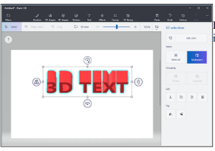
Paint 3D provides a collection of geometric shape that can be added to a drawing. Here are some 3D shapes.
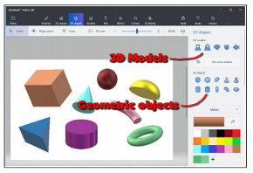
In addition to 3D geometric shapes, several 3D models are available.

Once you have created and selected a 3D Model, you can use the Stickers tool to add stickers or textures to the surface of the model.
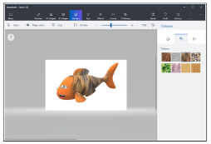
There is a large collection of 3D models available online. Use the 3D Library tool to get models.

One last thing to discuss is how the canvas is related to the position of 3D models. The canvas is like a sheet of paper that lies somewhere in the 3D space.
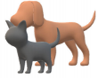
The illustrations show a dog and a cat. These models live in 3D space somewhere with respect to the canvas, and you can control who is in front of who.
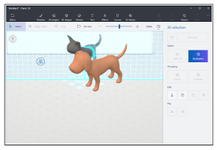
The tool on the left side of the selected 3D model is used to slide the model in and out of the 3D space.
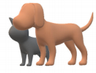
In the next illustration, the fill brush was used to paint the canvas green.
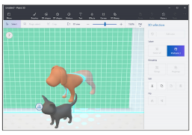
The dog model was selected and then dragged so that dog model was half in front of the green canvas, and half behind the canvas.

This provides a very brief tour of some of the features of Paint 3D. Perhaps it will give you enough information so that the YouTube videos about Paint 3D will make a little more sense.
